Instead of using

**AN ANONYMOUS CLASS**

you can use

**A LAMBDA EXPRESSION**

And if this just calls one method, you can use

**A METHOD REFERENCE**

**What is it?**

Java provides a new feature called method reference in Java 8. It is the shorthand syntax to a lambda expression that executes just one method.

**What syntax?**

In a method reference, you place the object (or class) that contains the method before the :: operator and the name of the method after it without arguments.

ObjectOrClass :: methodName

**There are four types of method references:**

* A method reference to ***a static method***
* A method reference to ***an instance method of an existing object***
* A method reference to ***an instance method of an arbitrary object of a particular type***
* A method reference to ***a constructor***

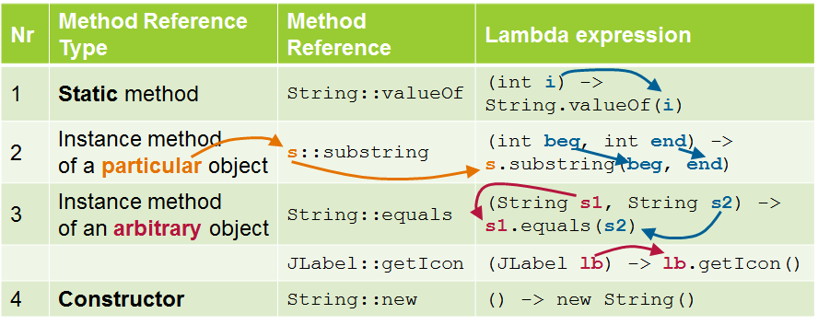

**What Advantages or Disadvantages?**

|  |
| --- |
| Advantages |
| 1. Make code CLEARER. A methods reference can't be used for any method. They can be used only to replace a single-method lambda expression. So to use a method reference you first need a lambda expression with one method. And to use a lambda expression you first need a functional interface, an interface with just one abstract method.   Example:  // Lambda Expression  Consumer<String> c = s -> System.out.println(s);  // Method References  Consumer<String> c = System.out::println; |
| 1. It is compact and easy form of lambda expression. Each time when you are using lambda expression to just referring a method, you can replace your lambda expression with method reference.   Example:  // Lambda Expression  Function<String, Double> doubleConvertorLambda=(String s) -> Double.parseDouble(s);  // Method References  Function<String, Double> doubleConvertor=Double::parseDouble; |

**Example**

| Method Reference Type | Example | | | |
| --- | --- | --- | --- | --- |
| Static method | class Numbers {  public static boolean isMoreThanFifty(int n1, int n2) {  return (n1 + n2) > 50;  }  public static List<Integer> findNumbers(  List<Integer> l, BiPredicate<Integer, Integer> p) {  List<Integer> newList = new ArrayList<>();  for(Integer i : l) {  if(p.test(i, i + 10)) newList.add(i);  }  return newList;  }  } | | | public class Test {  public static void main(String args[]) {  List<Integer> list = Arrays.asList(12,5,45,18,33,24,40);  }  } |
| **Equivalent** | **Syntax** | | **Example** |
| **Method References** | Class::staticMethod | | findNumbers(list, Numbers::isMoreThanFifty); |
| **Lambda Expression** | (args) -> Class.staticMethod(args) | | findNumbers(list, (i1, i2) -> Numbers.isMoreThanFifty(i1, i2)); |
| **Anonymous Class** |  | | findNumbers(list, new BiPredicate<Integer, Integer>() {  public boolean test(Integer i1, Integer i2) {  return Numbers.isMoreThanFifty(i1, i2);  }  }); |
| Instance method of an existing object | class Car {  private int id;  private String color;  // More properties  // And getter and setters  }  class Mechanic {  public void fix(Car c) {  System.out.println("Fixing car " + c.getId());  }  } | | | public class Test {  public void execute(Car car, Consumer<Car> c) {  c.accept(car);  }  public static void main(String args[]) {  final Mechanic mechanic = new Mechanic();  Car car = new Car();  }  } |
| **Equivalent** | | **Syntax** | **Example** |
| **Method References** | | obj::instanceMethod | execute(car, mechanic::fix); |
| **Lambda Expression** | | (args) -> obj.instanceMethod(args) | execute(car, c -> mechanic.fix(c)); |
| **Anonymous Class** | |  | execute(car, new Consumer<Car>() {  public void accept(Car c) {  mechanic.fix(c);  }  }); |
| Instance method of an arbitrary object of a particular type | class Shipment {  public double calculateWeight() {  double weight = 0;  // Calculate weight  return weight;  }  } | | | public class Test {  public List<Double> calculateOnShipments(  List<Shipment> l, Function<Shipment, Double> f) {  List<Double> results = new ArrayList<>();  for(Shipment s : l) {  results.add(f.apply(s));  }  return results;  }  public static void main(String args[]) {  List<Shipment> l = new ArrayList<Shipment>();  }  } |
| **Equivalent** | **Syntax** | | **Example** |
| **Method References** | ObjectType::instanceMethod | | calculateOnShipments(l, Shipment::calculateWeight); |
| **Lambda Expression** | (obj, args) -> obj.instanceMethod(args) | | calculateOnShipments(l, s -> s.calculateWeight()); |
| **Anonymous Class** |  | | calculateOnShipments(l, new Function<Shipment, Double>() {  public Double apply(Shipment s) { // The object  return s.calculateWeight(); // The method  }  }); |
| Constructor | **Equivalent** | **Syntax** | | **Example** |
| **Method References**  (no arguments) | ClassName::new | | Supplier<List<String>> s = ArrayList::new;  List<String> l = s.get(); |
| **Lambda Expression**  (no arguments) | () -> new ClassName() | | Supplier<List<String>> s = () -> new ArrayList<String>();  List<String> l = s.get(); |
| **Anonymous Class**  (no arguments) |  | | Supplier<List<String>> s = new Supplier() {  public List<String> get() {  return new ArrayList<String>();  }  };  List<String> l = s.get(); |
| **Method References**  (an argument) | ClassName::new | | Function<String, Integer> f = Integer::new;  Integer i = f.apply(100); |
| **Lambda Expression**  (an argument) | (args) -> new ClassName(args) | | Function<String, Integer> f = s -> new Integer(s);  Integer i = f.apply(100); |
| **Anonymous Class**  (an argument) |  | | Function<String, Integer> f =  new Function<String, Integer>() {  public Integer apply(String s) {  return new Integer(s);  }  };  Integer i = f.apply(100); |
| **Equivalent** | **Syntax** | | **Example** |
| **Method References**  (two arguments) | ClassName::new | | BiFunction<String, String, Locale> f = Locale::new;  Locale loc = f.apply("en","UK"); |
| **Lambda Expression**  (two arguments) | (args, args2) -> new ClassName(args, args2) | | BiFunction<String, String, Locale> f = (lang, country) -> new Locale(lang, country);  Locale loc = f.apply("en","UK"); |
| **Anonymous Class**  (two arguments) |  | | BiFunction<String, String, Locale> f = new BiFunction<String, String, Locale>() {  public Locale apply(String lang, String country) {  return new Locale(lang, country);  }  };  Locale loc = f.apply("en","UK"); |

**Method References**

**จุดสำคัญ (Key Points)**

* A method reference is the shorthand syntax to a lambda expression that executes just one method.

Method reference เป็น syntax อย่างย่อ ของ Lambda Expression ที่มีการประมวลผลด้วย method เดียว

* The syntax of a lambda expression is:

ObjectOrClassName :: methodName

* In a method reference, you place the object (or class) that contains the method before the :: operator and the name of the method after it without arguments.

ใน Method Reference เราจะเขียน object หรือ class ไว้หน้า :: แล้วตามด้วยชื่อ method ใน class นั้น โดยไม่ต้องระบุ Arguments

* There are four types of method references:

A method reference to **a static method**

A method reference to **an instance method of an arbitrary object of a particular type**

A method reference to **an instance method of an existing object**

A method reference to **a constructor**

* For static methods, we have a lambda expression like the following:

(args) -> Class.staticMethod(args)

* That can be turned into the following method reference:

Class::staticMethod

* For instance methods of objects of a particular type, we have a lambda expression like the following:

(obj, args) -> obj.instanceMethod(args)

**จุดสำคัญ (Key Points) - ต่อ**

* Where an instance of an object is passed as an argument and one of its methods is executed with some optional(s) parameter(s).

เป็นที่ให้ Object ที่ถูกสร้างขึ้น ส่งผ่านเป็น argument และใช้ method หนึ่งในนั้น ถูกประมวลผลด้วยพารามิเตอร์ที่มีเงื่อนไขบางอย่าง

**ตัวอย่าง**

(obj, args) -> obj.instanceMethod(args)

เปลี่ยนเป็น

ObjectType::instanceMethod

* And that can be turned into the following method reference:

ObjectType::instanceMethod

* For instance methods of existing objects, we have a lambda expression like the following:

(args) -> obj.instanceMethod(args)

* That can be turned into the following method reference:

obj::instanceMethod

* For creating objects (calling a constructor), we have a lambda expression like the following:

(args) -> new ClassName(args)

* That can be turned into the following method reference:

ClassName::new